

West Coast Collaborative
Specialist Mathematics Investigation 2, 2016
Vector Product (Cross Product)
Take Home Section – due Thursday 28 April

Validation of your findings will take place on that day, with 100% weighting on the validation. Calculator but no notes will be allowed in the validation.

Name: _______________________________

In this course, you have learned about the scalar product or dot product of two vectors.

You will also be learning about vectors in three dimensions, and a description of a third unit vector, k, which is perpendicular to the unit vectors i and j, is given on page 112 of the A.J. Sadler text.

In this investigation we will briefly examine the vector product or cross product.
The definitions given below shall be restated in the in-class investigation.

The vector product or cross product of two vectors a and b is a vector v which is written as:
v = a x b
and is defined as follows:

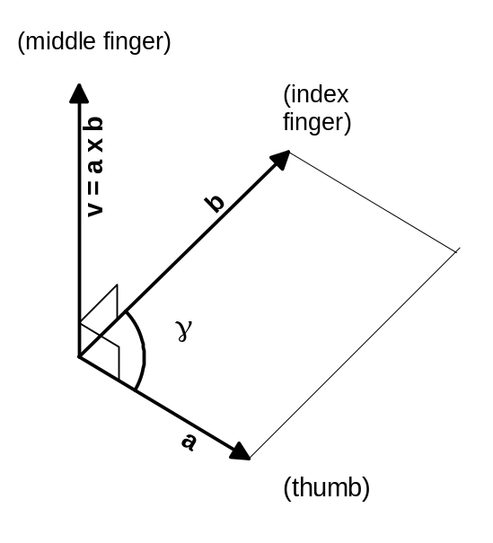If a and b have the same or opposite direction or either a or b is zero then v = a x b = 0, otherwise;

v = a x b is the vector whose length is equal to the area of the parallelogram with a and b as adjacent sides and whose direction is perpendicular to both a and b and is such that a, b, v, in this order, form a right-handed triple or right handed triad, as shown in the diagram.

The term right-handed is derived from the fact that the vectors a, b, v, in this order, assume the same orientation as the thumb, index finger and middle finger of the right hand when held as indicated in the diagram.

The parallelogram with a and b as adjacent sides has the area 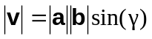
Where γ is the angle between a and b.
Suppose that the vectors a, b, and v are represented in component form with respect to a right-handed, three dimensional Cartesian coordinate system, with unit vectors i, j and k in the directions x, y and z respectively.
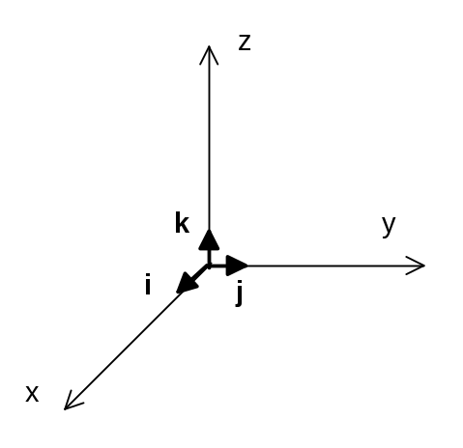
Let 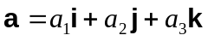 and 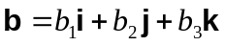

Then,
(2)

Equation (2) is not too difficult to memorise if it is interpreted as the expansion of a third order determinant, where unit vectors: i, j and k are in the first (top) row; the unit vector components of vector a are in the second (middle) row; and the unit vector components of vector b are in the second (bottom) row:
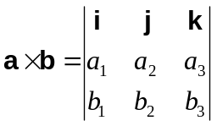

which expands to 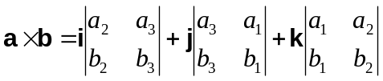

which expands to

Finally, if v = a x b , and the component vectors of v are v₁, v₂ and v₃, then the magnitude of v is |v| and is given by:

|v| = |v₁i + v₂j+ v₃k| , where 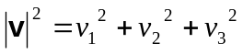
Also note that 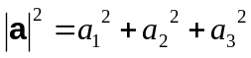 and 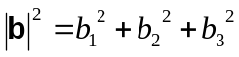

Example

With respect to a right handed Cartesian coordinate system, if 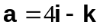and 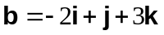
Then
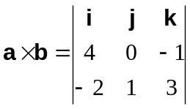
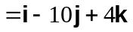

and 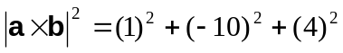

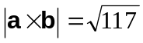

Note1) vector v = a x b is perpendicular to both vector a and vector b.

Note 2) The magnitude of v is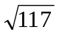, which is also the area of the parallelogram formed in space with the vectors a and b as adjacent sides.

QUESTION

If a = 2i +3j – 4k and b = -3i + 2j + 3k then determine the following:

( a ) a x b ( b )⏐ a x b ⏐

( c ) b x a ( d ) the angle between
a and b

